|  |
| --- |
| Service Guard Cluster –  FS extension by adding new LUN’s |
| For CATS Physical Servers |
| Recipients: |
| Remarks : |

|  |  |  |  |
| --- | --- | --- | --- |
| Version No | Date | Author | Modification Type |
| v1.0 | 26-Aug-2021 | Kiran Thomas Johnson | Document Inception |
|  |  |  |  |
|  |  |  |  |
|  |  |  |  |

Table of Contents

1 Introduction 4

1.1 Objective 4

1.2 Scope 4

2 Technical Dependency 5

3 Pre Requisites 6

4 Standard Input 7

5 Pre-Checks 8

6 Pre-Activity Log 9

7 Execution Steps 10

8 Conditional Actions 11

9 Expected Output 12

10 Post Checks 13

11 Post Check Logs 14

12 Log Comparision 15

13 Validation Report 16

14 Error Handling 17

15 Post Execution Document Update 18

16 Roll Back 19

# Introduction

## Objective

The Objective of the document is to extend the volume group or finally extend a filesystem, which is used by a Cluster package (resource) - by adding new LUNs and thus extending the VG and subjected LV.

## Scope

The scope of this document is only limited to CATS Physical Servers which are having HP Service Guard Cluster setup

# Technical Dependency

None

# Pre Requisites

The confirmation from requestor on the size required for extension & confirmation regarding the Lun’s – whether the existing LUN to be extended or new Lun’s to be added. Also downtime for the packages so that we can extend the LV of the filesystem corresponding to that package.

4 Standard Input

None

5 Pre-Checks

None

6 Pre-Activity Log

None

7 Execution Steps

**Adding new LUN’s and extending the Filesystem:**

When there is request (RITM) for Disk extension, the requestor may be specifying to add new Lun’s rather than to extend the existing Lun’s. We will be getting the details mentioned in the attached excel (in RITM) saying to add new LUN’s. In the first CTASK – we will be doing the analyses and will share the WWN’s of our HBA Ports. Then as per the second CTASK getting opened with Stockage team, they will add new LUN’s as requested. The third CTASK will be for us again for scanning the LUN’s and for extending VG, and the respective LV of the package which needs extension.

1. Check for # ***df -h*** output to find out the filesystem details

[root@slzusncsgl19 by-id]# df -h

Filesystem Size Used Avail Use% Mounted on

devtmpfs 16G 0 16G 0% /dev

tmpfs 16G 304K 16G 1% /dev/shm

tmpfs 16G 58M 16G 1% /run

tmpfs 16G 0 16G 0% /sys/fs/cgroup

/dev/mapper/vg00-root 5.8G 4.9G 667M 89% /

/dev/mapper/vg00-nmonlv 58M 8.7M 45M 17% /nmon

/dev/mapper/vg00-home 488M 888K 452M 1% /home

/dev/sda1 976M 177M 733M 20% /boot

/dev/mapper/vg00-tmp 2.0G 6.1M 1.8G 1% /tmp

/dev/mapper/vg01-data 7.1G 151M 6.6G 3% /data

/dev/mapper/vg00-opt 2.9G 582M 2.2G 21% /opt

/dev/mapper/vg00-var 3.9G 2.2G 1.5G 61% /var

tmpfs 5.0M 0 5.0M 0% /var/cache/salt/minion/proc

/dev/mapper/vg_ZUS10_Donnees-lv_zus10--data 6.8G 142M 6.3G 3% /MYS/ZUS10/Donnees/MYS

/dev/mapper/vg_ZUS10_Procparm-lv_zus10--proc 6.8G 32M 6.4G 1% /MYS/ZUS10/Procparm/MYS

tmpfs 3.2G 0 3.2G 0% /run/user/0

/dev/mapper/vg_ZUS11_Exports-lv_zus11--data 6.8G 32M 6.4G 1% **/data/ZUS11/Donnees/NFS**

Steps in short:-

1) Add LUN's to multipath.conf and reload service

2) Raid device creation

3) Update the mdadm config file and sync to other node

4) Stop the cluster package(s) as required

5) Activate the mdraid devices

6) Add tags to the respective VG’s

7) Activate the VG’s to be extended

8) VG extension

9) LV extend

10) Deactivate VG’s

11) Delete tags in VG’s

12) Stop mdraid devices

13) Update package config file with new raid device

14) Apply the new configuration

15) Start the cluster packages.

The filesystem which we want to extend is “/data/ZUS11/Donnees/NFS “ and the VG name is “vg_ZUS11_Exports” and the LV is “ lv_zus11--data “.

Once SAN team closes their CTASK, we can check for the LUN’s visibility at OS end, by rescanning

# ***rescan-scsi-bus.sh***

[root@slzusncsgl19 by-id]# rescan-scsi-bus.sh

Scanning SCSI subsystem for new devices

Scanning host 0 for SCSI target IDs 0 1 2 3 4 5 6 7, all LUNs

Scanning for device 0 0 0 4194240 ...

OLD: Host: scsi0 Channel: 00 Id: 00 Lun: 4194240

Vendor: HP Model: P220i Rev: 8.32

Type: RAID ANSI SCSI revision: 05

------------------ Output omitted -------------------

OLD: Host: scsi2 Channel: 00 Id: 03 Lun: 06

Vendor: EMC Model: SYMMETRIX Rev: 5977

Type: Direct-Access ANSI SCSI revision: 05

**0 new or changed device(s) found.**

**0 remapped or resized device(s) found.**

**0 device(s) removed.**

Since we are not able to get the new Luns after scanning (we cannot reboot the Server as we have downtime only for the package which requires extension and not for any other packages or not for Server), we need to get the LUN WWN’s added into ***/etc/multipath.conf*** file.

Before adding the new LUN’s into multipath.conf file:

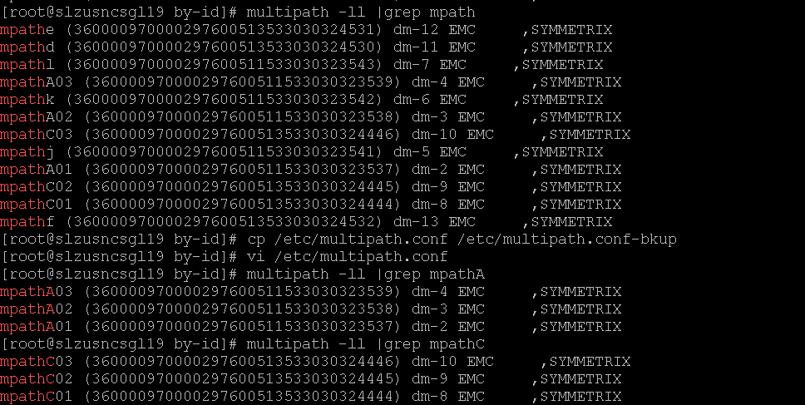

Always take a backup of any configuration files {especially under /etc} before you make any changes.

# ***cp /etc/multipath.conf /etc/multipath.conf-bkup***

Now edit the ***/etc/multipath.conf*** file so as to add the new LUN’s as given below ( entries for mpathC04, mpath C05, mpathC06 & mpathA04, mpathA05, mpath06 )

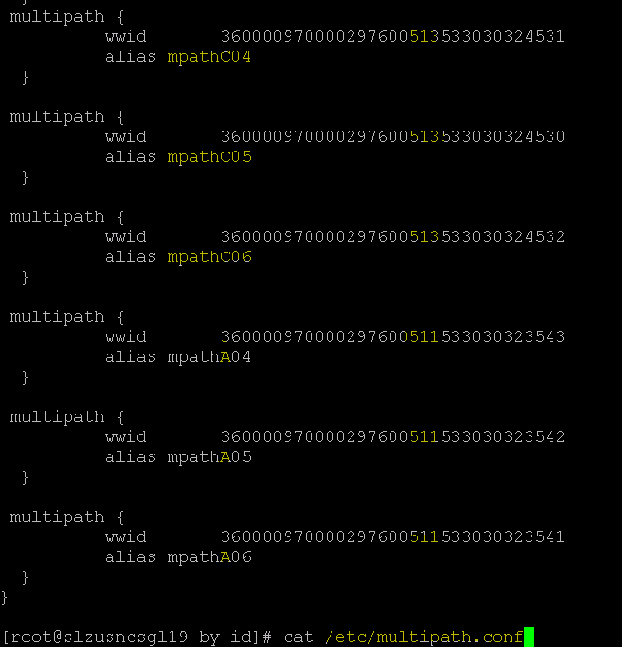

In our case, these are the 6 responsible LUN’s –

360000970000297600**511**533030323**541** = alias name mpathA06

360000970000297600**511**533030323**542** = alias name mpathA05

360000970000297600**511**533030323**543 =** alias name mpathA04

360000970000297600**513**533030324**530** = alias name mpathC05

360000970000297600**513**533030324**531 =** alias name mpathC04

360000970000297600**513**533030324**532** = alias name mpathC06

These are of 8 GB each (physically located in our main 2 DC’s - DID & DAL for redundancy. We can see the LUN WWN’s having 511 & 513 in the middle of the number as highlighted and thus we are creating Alias name in /etc/multipath.conf accordingly, and in our case as we can see 511’s are named as mpathA and 513’s are named as mpathC) comprising the raid devices which in turn are used for our PV and VG from which we have created the subjected Filesystems.

Once added into /etc/multipath.conf file, we can reload the service

# ***systemctl reload multipathd***

And thus we will be seeing the LUN’s finally scanned and visible.

[root@slzusncsgl19 by-id]# multipath -ll |grep mpathA

mpathA06 (360000970000297600511533030323541) dm-5 EMC ,SYMMETRIX

mpathA05 (360000970000297600511533030323542) dm-6 EMC ,SYMMETRIX

mpathA04 (360000970000297600511533030323543) dm-7 EMC ,SYMMETRIX

mpathA03 (360000970000297600511533030323539) dm-4 EMC ,SYMMETRIX

mpathA02 (360000970000297600511533030323538) dm-3 EMC ,SYMMETRIX

mpathA01 (360000970000297600511533030323537) dm-2 EMC ,SYMMETRIX

[root@slzusncsgl19 by-id]# multipath -ll |grep mpathC

mpathC06 (360000970000297600513533030324532) dm-13 EMC ,SYMMETRIX

mpathC05 (360000970000297600513533030324530) dm-11 EMC ,SYMMETRIX

mpathC04 (360000970000297600513533030324531) dm-12 EMC ,SYMMETRIX

mpathC03 (360000970000297600513533030324446) dm-10 EMC ,SYMMETRIX

mpathC02 (360000970000297600513533030324445) dm-9 EMC ,SYMMETRIX

mpathC01 (360000970000297600513533030324444) dm-8 EMC ,SYMMETRIX

We can see in the ***/etc/mdadm.conf*** file that the last used /dev/md# device is configured as /dev/md2



And for our new LUN’s we will create the raid device = /dev/md3

# ***mdadm --create --verbose /dev/md3 --level=1 --raid-devices=2 /dev/mapper/mpathA04 /dev/mapper/mpathC04***

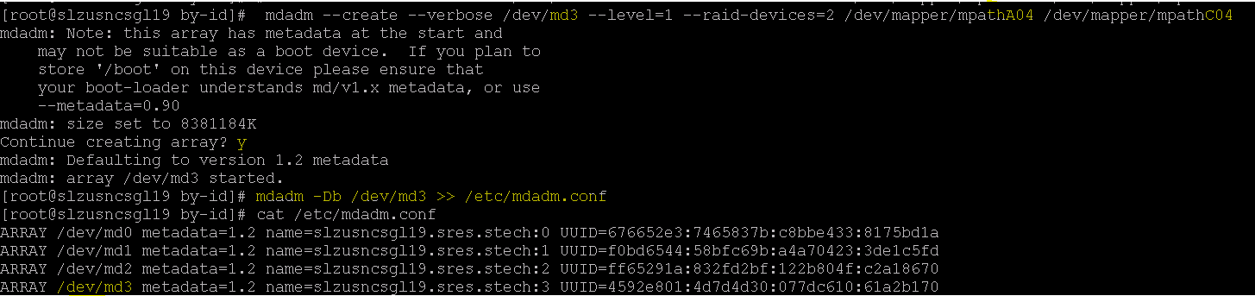

Once the /dev/md3 is created, then the corresponding details (UUID) can be found out by the command

# ***mdadm -Db /dev/md3***

This value need to be added into the /etc/mdadm.conf file as well (as shown above)

# ***mdadm -Db /dev/md3 >> /etc/mdadm.conf***

Also the same mdadm.conf file should be updated in the other node too.

[root@slzusncsgl19 by-id]# ***scp /etc/mdadm.conf slzusncsgl20:/etc/mdadm.conf***

mdadm.conf 100% 400 1.4MB/s 00:00

The respective array disks (dm disks) can be found out by the command

# ***mdadm --detail /dev/md3***

Here we can see the md3 raid device is made up of 2 Array disks – dm-7 & dm-12, and we can see the LUN details and mpath name alias we set already (in /etc/multipath.conf file) in the # ***multipath -ll*** command output too.

***# multipath -ll |grep dm-7***

***# multipath -ll |grep dm-12***

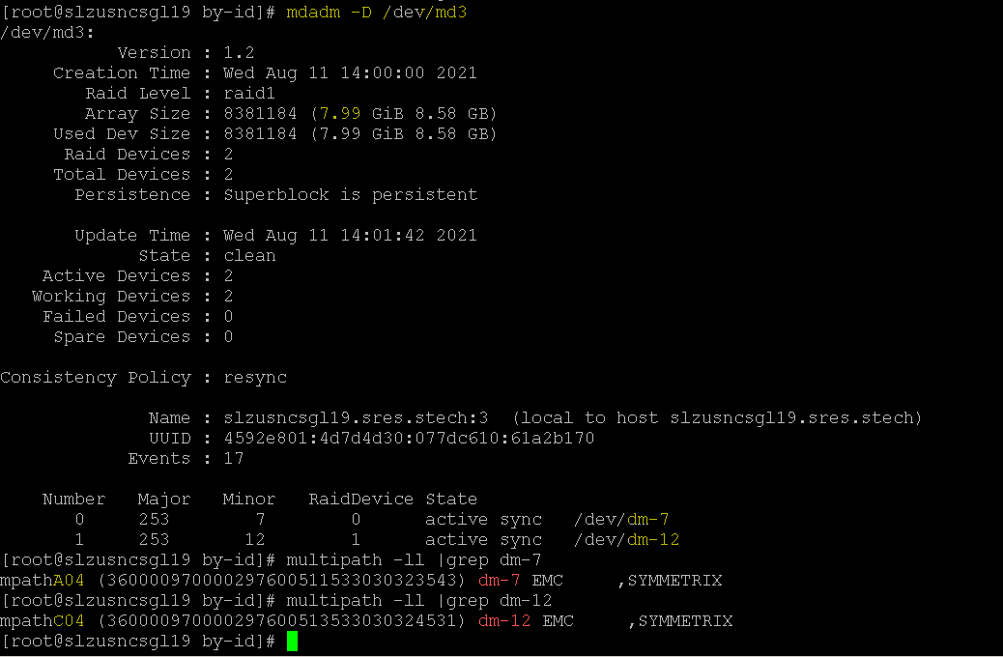

The respective packages, of the filesystem which we are going to extend; should be stopped first (Halted).

# ***cmhaltpkg <pkg name>***

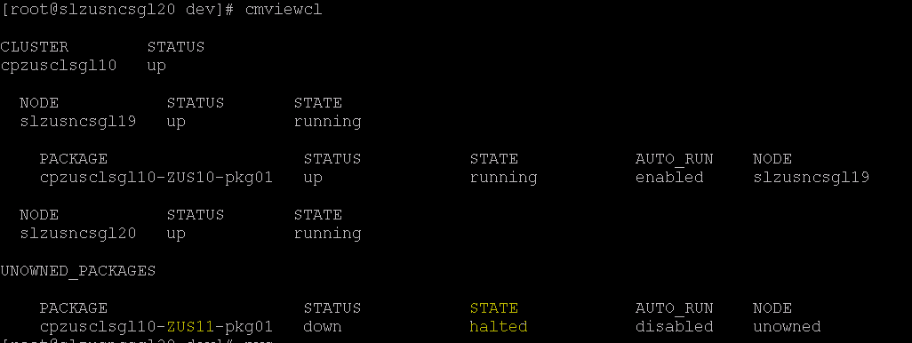

We now verified the package status by running # ***cmviewcl*** and can see that the subjected package is down***.***

Cluster configuration files are available under ***“/usr/local/cmcluster/conf/*** “ directory and you can easily go to it by the environment variable ***cd $SGCONF***

The packages’ configuration file is available under the path ***– “ /usr/local/cmcluster/conf/PACKAGES “***

Also with the command # cmgetconf –p >pkg name>, too we can find out the details.

# ***cmgetconf -p cpzusclsgl10-ZUS11-pkg01 |egrep -v "^\s*(#|$)"|grep raid_device |awk '{print $2}'***

We can see in the output of the above command that currently the VG is comprised of the raid device “/dev/md2” alone and we will be finally adding /dev/md3 raid device too into this VG.

For this, we need to activate the existing raid device = /dev/md2

# ***mdadm -A -R /dev/md2***

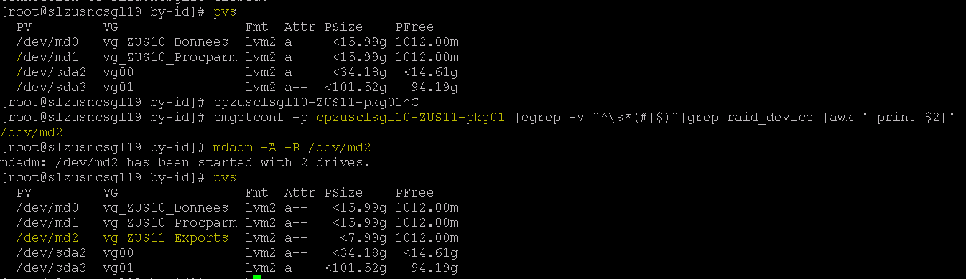

In pvs & vgs commands now we can see the activated pv & vg.

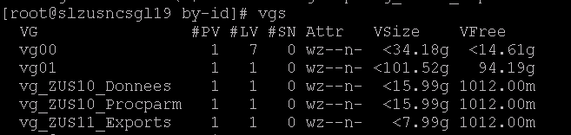

The VG is “vg_ZUS11_Exports” and we will extend this by adding the new Raid Device (/dev/md3) which we created earlier.

For this, we have to add tag for the VG & will activate the VG.

[root@slzusncsgl19 by-id]# ***vgchange --addtag `hostname` vg_ZUS11_Exports***

Volume group "vg_ZUS11_Exports" successfully changed

[root@slzusncsgl19 by-id]# ***vgs -o +tags***

VG #PV #LV #SN Attr VSize VFree VG Tags

vg00 1 7 0 wz--n- <34.18g <14.61g

vg01 1 1 0 wz--n- <101.52g 94.19g

vg_ZUS10_Donnees 1 1 0 wz--n- <15.99g 1012.00m slzusncsgl19.sres.stech

vg_ZUS10_Procparm 1 1 0 wz--n- <15.99g 1012.00m slzusncsgl19.sres.stech

vg_ZUS11_Exports 1 1 0 wz--n- <7.99g 1012.00m slzusncsgl19.sres.stech

[root@slzusncsgl19 by-id]# ***vgchange -ay vg_ZUS11_Exports***

1 logical volume(s) in volume group "vg_ZUS11_Exports" now active

Now we can extend the VG by adding the new raid device

# ***vgextend vg_ZUS11_Exports /dev/md3***

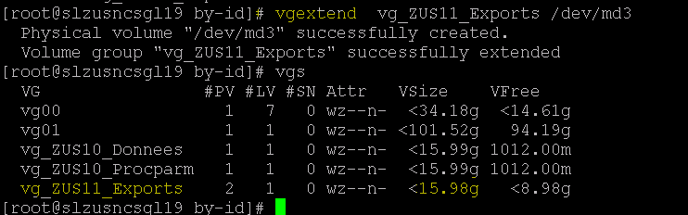

We can now see the new size - i.e, 8 GB added into the VG and VG having 8 GB+ free space available for further LV extension.

One this is completed, we have to do the steps in reverse order - that is deactivation of VG, delete tag & Stop the raid devices (now /dev/md3 also added up and hence stoppage required for that raid device too).

This way we can make sure there is no further usage of the VG / Raid device and we can make necessary changes to the configuration file of our package further.

# ***vgchange -an vg_ZUS11_Exports***

***# vgchange --deltag `hostname` vg_ZUS11_Exports***

***# vgs -o +tags***

***# mdadm -S /dev/md2***

***# mdadm -S /dev/md3***

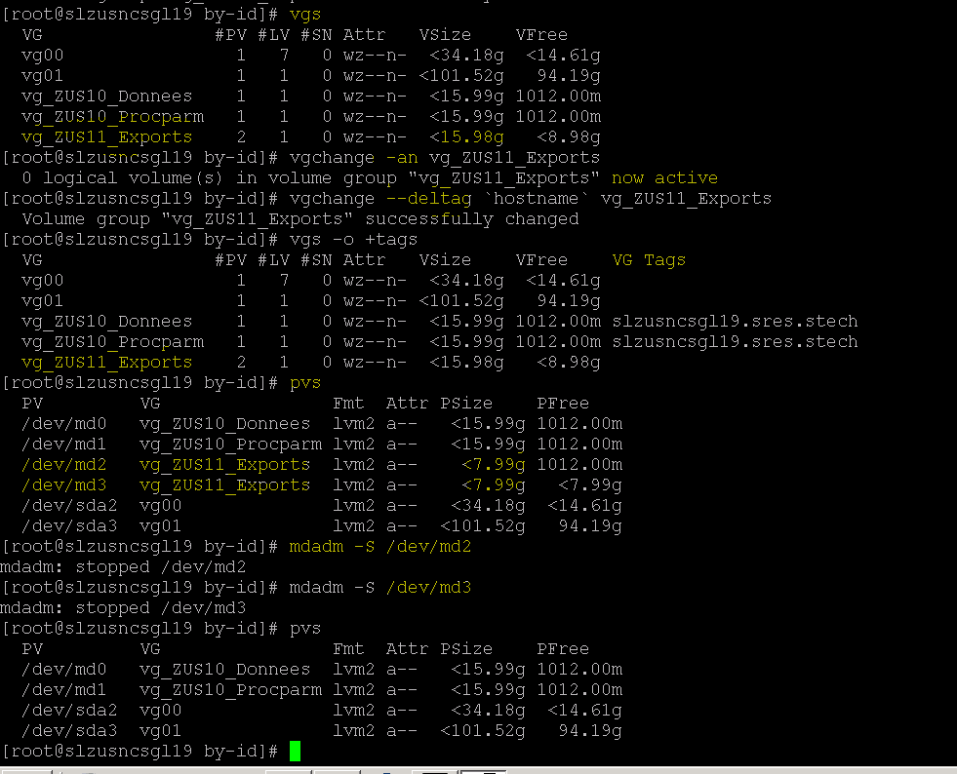

Now we will add our new raid device details to the config file which having the running configuration of our package.

[root@slzusncsgl19 by-id]# **cd $SGCONF**

[root@slzusncsgl19 conf]# pwd

/usr/local/cmcluster/conf

[root@slzusncsgl19 conf]# **cd PACKAGES/cpzusclsgl10-ZUS11-pkg01**

[root@slzusncsgl19 cpzusclsgl10-ZUS11-pkg01]# ls -lart

total 80

drwxr-x---. 4 root root 4096 Jul 27 18:45 ..

-rw-r-----. 1 root root 73657 Jul 27 19:10 **ZUS11-pkg01.conf**

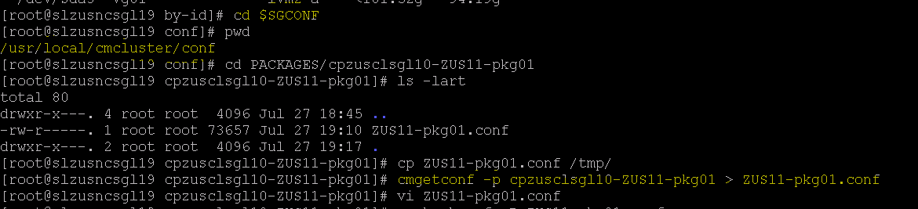

We can see in the above that the current running configurations is updated into the package config file.

# **cmgetconf -p cpzusclsgl10-ZUS11-pkg01 > /usr/local/cmcluster/conf/ PACKAGES/cpzusclsgl10-ZUS11-pkg01/ZUS11-pkg01.conf**

Now we have to add the new raid device details into the config file.

**xdc/xdc/raid_device /dev/md3**

**xdc/xdc/device_0 /dev/mapper/mpathA04**

**xdc/xdc/device_1 /dev/mapper/mpathC04**

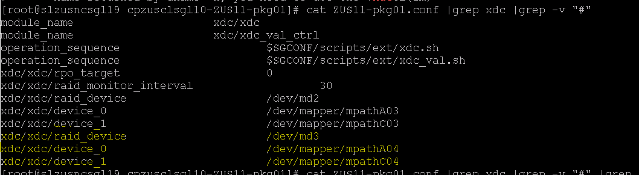

Once its added the new config file needs to be checked for syntax errors (validations) and once its success, we need to apply this configuration into the current running values.

***# cmcheckconf -P ZUS11-pkg01.conf***

***# cmapplyconf -P ZUS11-pkg01.conf***

Once the new configuration is updated, we are good to start the package.

# ***cmrunpkg -n slzusncsgl19 cpzusclsgl10-ZUS11-pkg0***

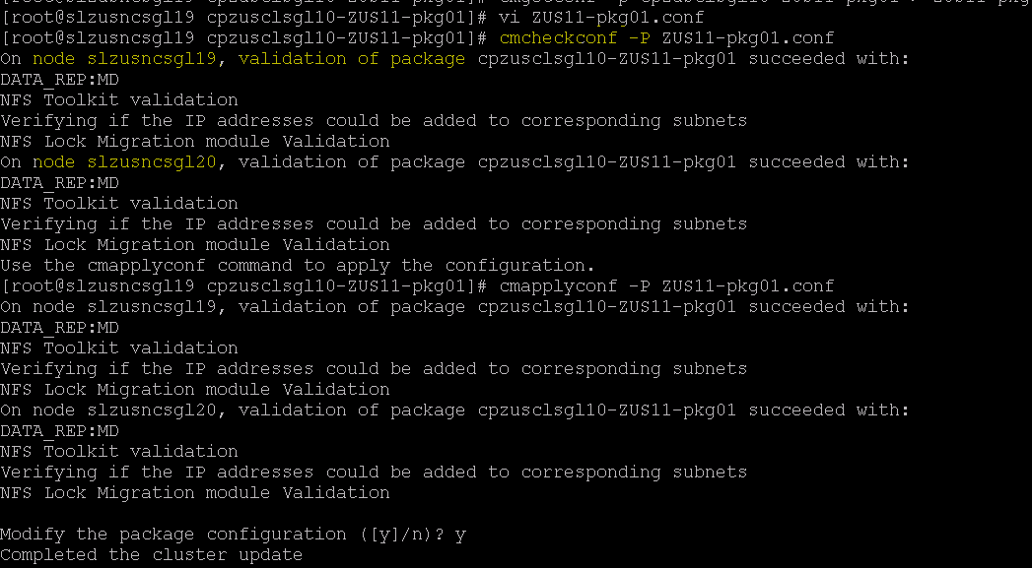

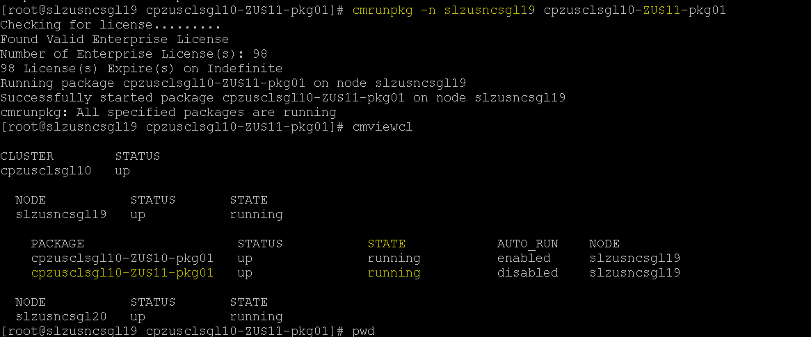

8 Conditional Actions

None

9 Expected Output

None

10 Post Checks

None

11 Post Check Logs

None

12 Log Comparision

None

13 Validation Report

None

14 Error Handling

None

15 Post Execution Document Update

None

16 Roll Back

None